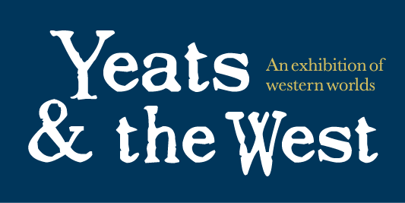

Western Worlds

a day for Yeats & the West

Friday 27th November 2015

Hardiman Research Building, NUI Galway

William Butler Yeats, poet, playwright, politician, and Nobel prize-winner for literature, always looked west. The Yeats & the West exhibition at NUI Galway, with rare books, art, music, drama, and film, discovers what the west meant to him, and what this means for us. Part of the Yeats & the West programme, the day event Western Worlds tells the story of the western cultural revolution that shaped modern Ireland. Featuring talks on W.B.Yeats’s poems, plays, artistic collaborations and love affairs, and featuring his co-conspirators Jack B.Yeats, J.M. Synge, Padraic Pearse and Eva Gore-Booth, it includes dramatized poetry readings and an exclusive interview with the artist John Behan about his current exhibitions of Yeatsian sculptures and drawings. Western Worlds tells a story of going west to find those places, real and imaginative, that change our sense of where and who we are.
yeatsandthewest.org

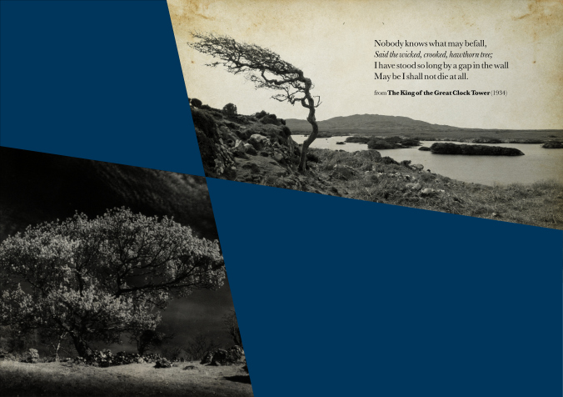

Western Worlds: A Symposium
Bridge Seminar Room, Hardiman Research Building

10.45am Welcome & Kisses Adrian Frazier
Yeats & Maud Gonne: The Meaning of Their Kisses

12pm Memories Brian Arkins
W.B.Yeats & G.M. Hopkins

Barry Houlihan
‘Suffering Spirits and Remorseful Dead’: Remembrance and Re-enactments in the plays of W.B.Yeats

1pm Lunch

2pm Arts
Deirdre Ní Chonghaile
‘Listening to this rude and beautiful poetry’: J.M. Synge as song collector in the Aran Islands

Adrian Paterson
W.B. Yeats among the Arts

3.30pm Revivals Mary Harris
Realism, Idealism and the Gaelic Revival

Maureen O’Connor
Eva Gore-Both’s Vague Utopia

4.30pm Coffee the curators of Yeats & the West
informal exhibition tour

(from 5pm in Special Collections)

5.30pm Poems David Clare & Deirdre Clare
dramatic readings

6.30pm Bulls John Behan
the Bull of Sheriff Street in conversation

Friday 27th November 2015 yeatsandthewest.org

